Statement of Dalaila

2019

|  |  |  |  |
| --- | --- | --- | --- |
| Month | Amount | Credit | Cash |
| January | 94048 | 94048 | paid |
| February | 65145 | 65145 | paid |
| March | 77427 | 25132 | paid |
| April | 78455 | 34801 | paid |
| May | 77726 | 29077 | paid |
| June | 49574 | 34533 | paid |
| July | 41709 | 34685 | paid |
| August | 66025 | 38984 | paid |
| September | 67177 | 33853 | paid |
| October | 127740 | 34840 | paid |
| November | 123116 | 33750 | paid |
| December | 60946 | 42272 | PAID 100000  REM-->3218🡪Paid |
|  |  |  |  |

Partial paid for September and October

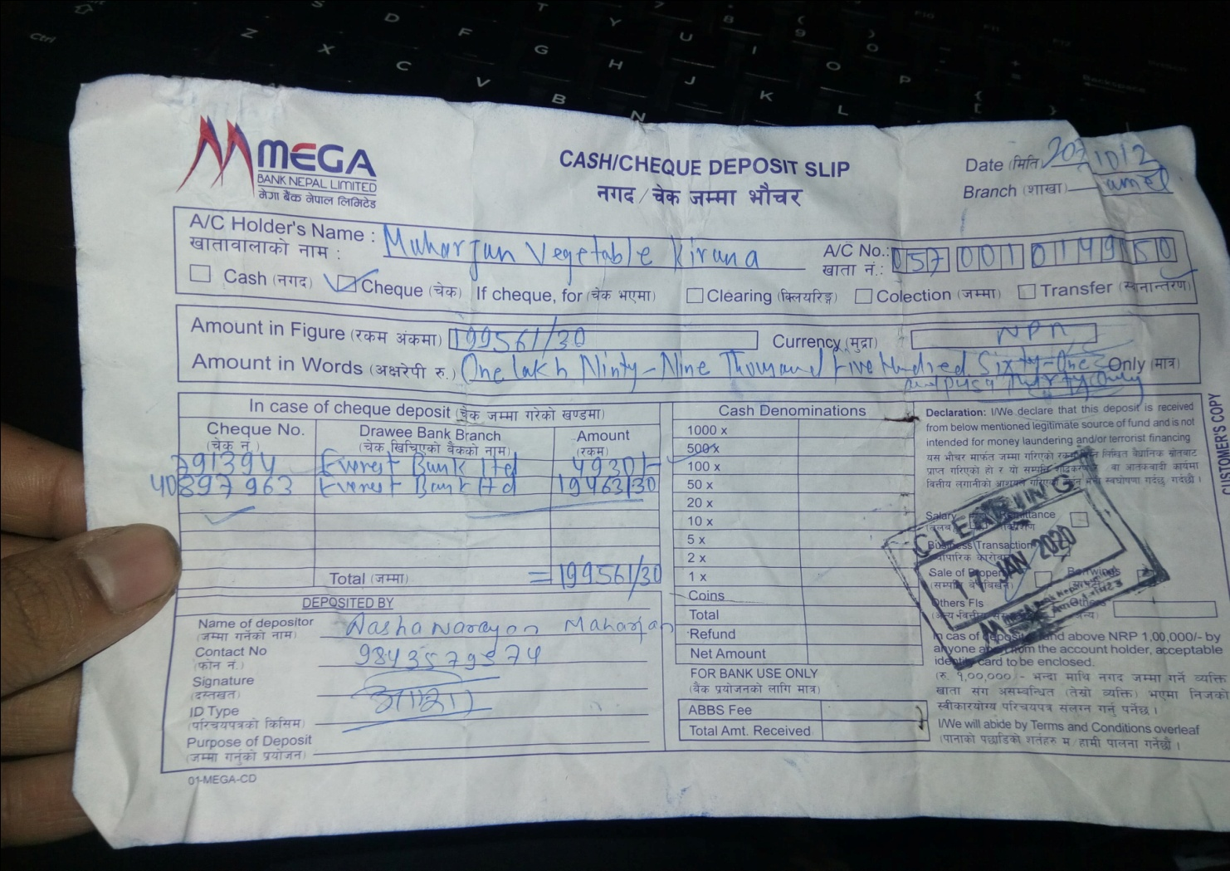



Remaining of October and full payment of November

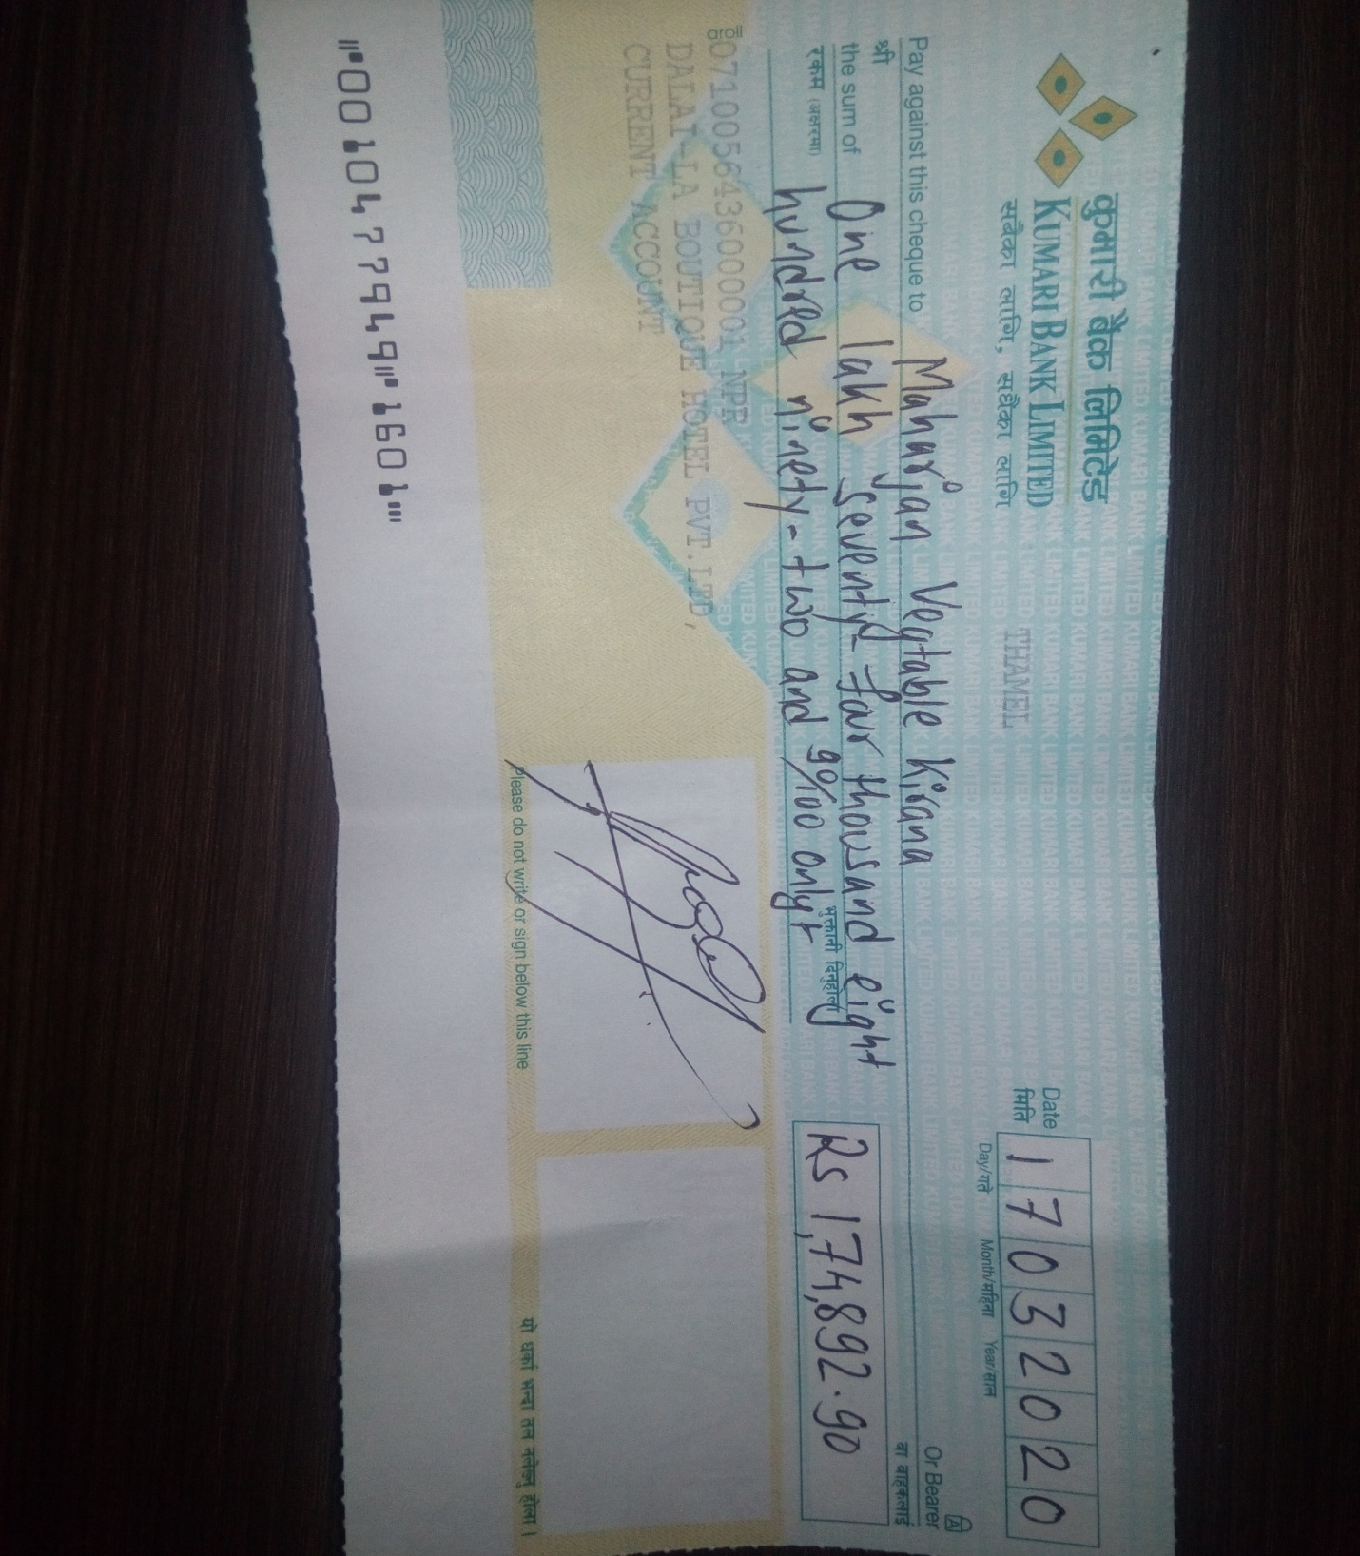

For dec 2019

**19/10/2020🡪50,000(partially)**

**17/02/2021🡪50,000(partially)**